**Unit 4 Movie Database Alterations with SQL**

Corey Crooks

Purdue University Global

IT234 – Leon King

May 9, 2021

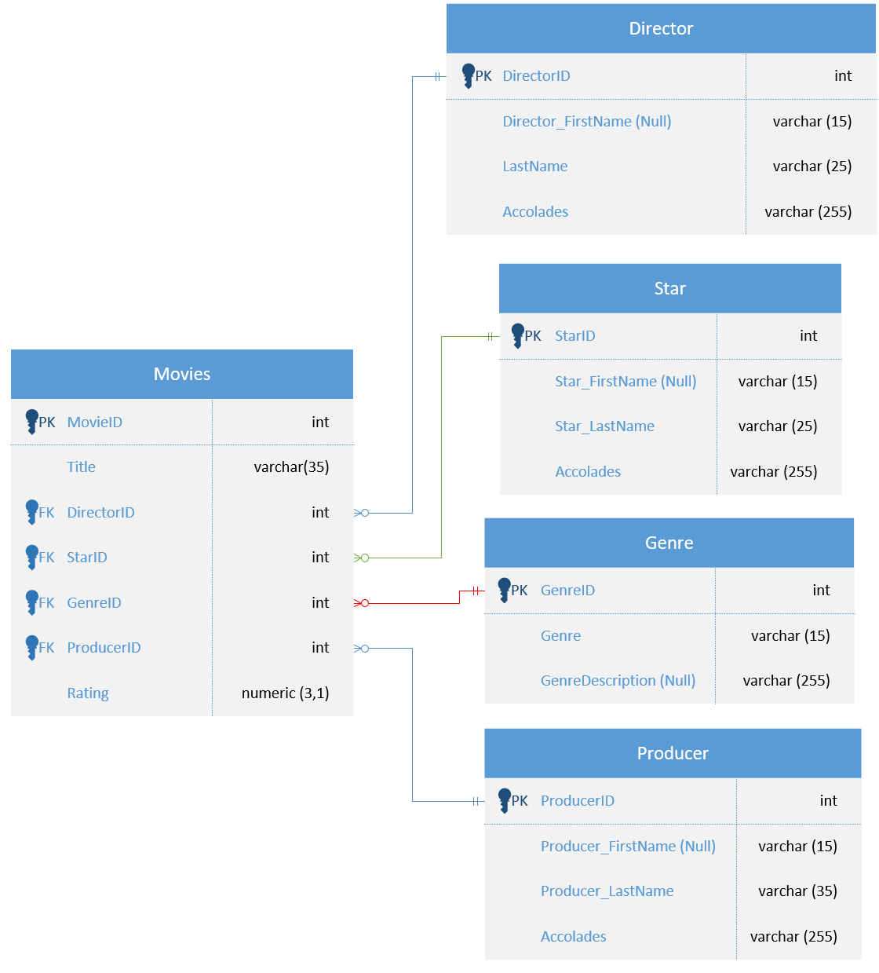

This is the updated model of my database featuring a new Producer entity, and some changes to all other entities.

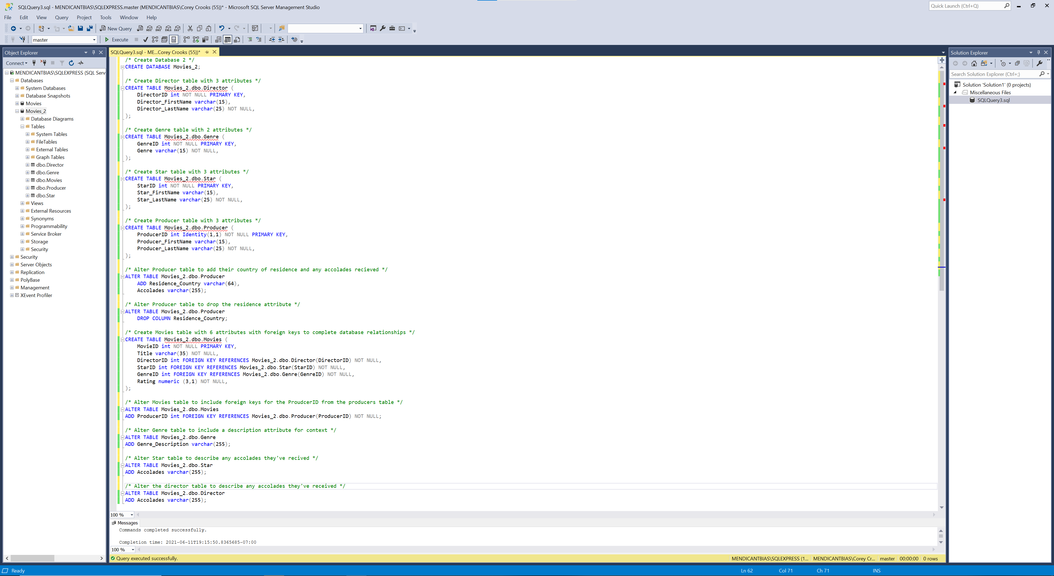

A screenshot of the Microsoft SQL Server Studio showing the SQL Code required to create the Movies_2 database, as well as the Object Viewer to show that it works. The red squiggly lines under the Director, Genre, Star, and Producer CREATE statements signify there are already tables existing with those names. The code was executed previously to this screenshot being recorded, so that is completely normal.

On the previous page is the SQL code required to set up the database, as well as add any necessary changes.

The large part of this SQL is the exact same as last week, but there are some additions to comply with this week’s assignment. Firstly, I created a Producer table in the Movies_2 database. This table has the ProducerID as a non-NULL primary key integer. The second attribute is reserved for the First Name which is a string of up to 15 letters. The third attribute is reserved for the Last Name, which will be a string of up to 35 letters, and cannot be left blank.

The next SQL statement I wrote involves altering the Producer table. It will add an attribute for the Residence Country of the producer in question as well as a space for any accolades the producer has earned in their career. The country shall be a string of up to 64 characters, and the accolades attribute will be a string of up to 255 characters. Both may be left blank.

Moving on, I wrote another ALTER TABLE statement for the producer after deciding that the residence attribute was unnecessary. Needless to say, this statement alters the Producer table to get rid of the residence attribute.

After that, I have an ALTER TABLE statement in order to add the ProducerID primary key of the Producer table into the Movies table as a foreign key. After all, it would be strange to not include producers in the movie information if we’re going through the trouble of adding everything else.

My next ALTER TABLE statement adds a description to the Genre entity in order to give the genre ID and name more context. This attribute is a string of up to 255 characters, and can be left blank.

My final two ALTER TABLE statements add an attribute to accolades similar to what is seen in the Producer table. These are strings of up to 255 characters, and can be left blank similar to how the Genre_Description attribute is set up.